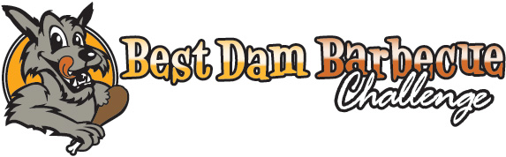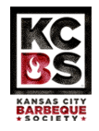
Memorial Day Weekend - May 27th – 28th, 2022 - Boulder City, Nevada
Competitive Team Registration Form
Team Information (please print legibly):

Team Name: On-Site Cell Phone:

Chief Cook: KCBS Number:

Email:

Address: City, State & Zip:

Event Days & Times
The Best Dam Barbecue Challenge is open to the public on Friday, May 27th from 4pm – 10pm and on Saturday, May 28th from 9am – 5pm. The Team Cook’s Meeting will be at 5pm on Friday, 5/27/22.

Set-Up Times
Set-Up will be on Thursday, May 26th from 12pm – 8pm and on Friday, May 27th from 8am – 3pm.

Space Usage Information
Size of the rig/trailer that will be in your space:
Count the complete size, including trailer hitches to absolute end of rig. Include any booths, trucks, and canopies you may be using.

Length: feet x Depth (curb to front): feet x Height: feet.

If not a standard configuration, please include a small drawing.
Spaces located on Colorado St. are limited to 15 feet in depth (due to the City of Boulder City’s requirements for emergency vehicle access). This will be strictly enforced by the Boulder City Fire Dept.

Fire Extinguisher Requirement
The City of Boulder City requires that all food vendor and competition booths be equipped with a 5 lb. ABC fire extinguisher with a current stamp (2022). Fire extinguishers must be in plain view and easily accessible, as the Boulder City Fire Department will conduct inspections prior to and during the event to ensure compliance. Smoking within vendor spaces is prohibited.

Challenge Entry & Space Fees
Registration Fee for one 40’ long space and entry into four individual, GC & RGC competitions: $375.00
  - Teams must submit entries for all four categories to be judged on Saturday, May 29th, 2021.
  - Teams accepted into the challenge will be confirmed within 7 days of application receipt.
  - A Late Fee of $35 will apply to all applications received after May 21ST, 2021.
  - EARLY BIRD SPECIAL: THIS YEAR TAKE $50.00 OFF YOUR REGISTRATION FEE AND ANOTHER $25.00 IF YOU ARE A PREVIOUS COMPETITOR IF PAID IN FULL BY APRIL 1ST 2022.

Generators & Electricity Options
The Best Dam Barbecue Challenge DOES PERMIT the use of generators (both in-vehicle and free-standing). The City of Boulder City requires that free-standing generators operate at a noise level of 90 decibels or below, be surrounded by a (small garden) fence to avoid a trip hazard and be located a minimum of 20’ from the cooking source/flame.

The City of Boulder City no longer provides the use of ‘spider boxes’ free of charge, so we must pass along a $60 fee for each 50 amp electrical outlet request. If you would like use of an
electrical outlet, please add an additional $60.

Please note: electricity is NOT AVAILABLE in all areas. (Optional) $60.00

What will you be using for power? Generator Electricity Both
Total Due and Check Enclosed for: $

Uncle Sam’s Piece of the Meat
Winnings of $600 or more require that we submit a 1099 Miscellaneous Income Tax Form to the IRS, therefore, winners of more than $600 in prize money will need to complete a W-9 Form prior to its issuance.

Prohibition of BBQ Samples
Southern Nevada Health Department regulations prohibit competitors from giving or selling open food products or tastings to the public. Violation of SNHD regulations will result in expulsion from the event with no fees refunded.

Registration Inclusions, Deadlines & Cancellations

The registration fee includes entry into:
One Team Competition Space
  - Individual Competitions for Chicken, Pork, Ribs and Brisket
  - Grand Champion Competition
  - Reserve Grand Champion Competition

New registrations will not be accepted after May 23rd, 2022.
.

Ice:
Ice will be available for purchase. One complimentary bag of 20 lb. ice for each competitor.

Area Preferences:
As has been the case in past years, we are unable to confirm with absolute certainly which space you will be assigned. We accept area preference requests in advance, but “stack” teams into the next available space within each area as they arrive.

Area preferences are taken on a first-come-first-saved basis, so if your registration is delayed and your top choices are taken, we can advise you of the remaining options when we confirm your registration. Register early if you desire a specific area!

- 1st Choice - 2nd Choice - 3rd Choice - 4th Choice

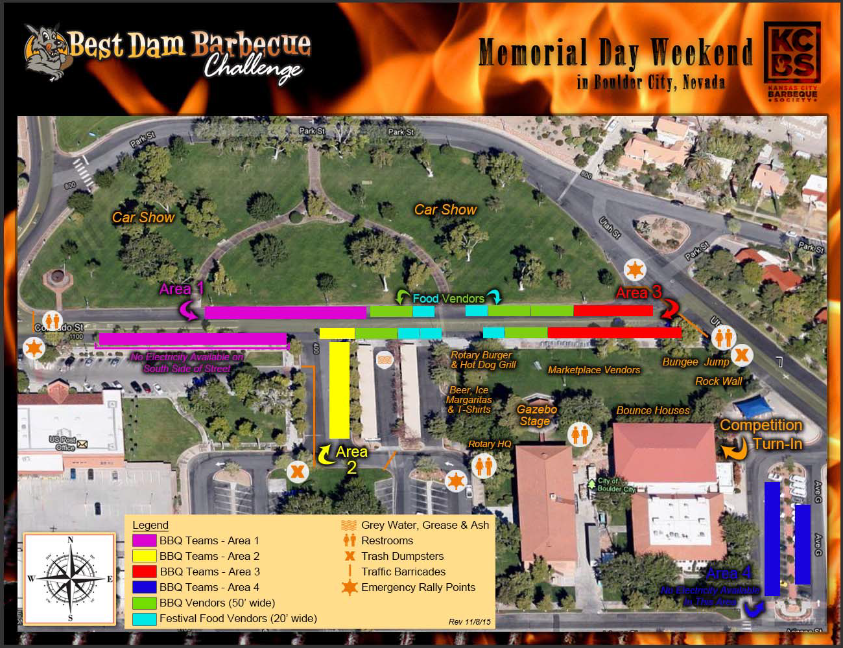

Liability & Media Usage Waiver:
In consideration of my participation in the Best Dam Barbecue and related events, intending to be legally bound thereby, I hereby for myself, my heirs, executors, and administrators, waive and release any and all rights and claims for damages I may have against the Rotary Club of Boulder City, Rotary International, the Best Dam Barbecue, the City of Boulder City, the host sponsors, and all of their representatives, successors, and assigns for any and all injuries suffered by myself, my heirs, executors, and administrators with respect to the Best Dam Barbecue. Further, I hereby grant full permission to the Best Dam Barbecue and/or agents authorized by them, to use any photographs, videotapes, motion pictures, recordings or any other record of the Best Dam Barbecue and related events for any legitimate reason.

I agree to abide by the rules and regulations of the Best Dam Barbecue as outlined above, as well as all rules and regulations stipulated by the Kansas City Barbeque Society.

Signature of Chief Cook: Date:

Remember to Enclose:
- Completed application – please include all pages
- Check IN FULL made payable to Boulder City Rotary Club or by credit card (Note a 3.5% surcharge is added)
Billing name on Credit Card_____________________Billing Address__________________
Credit Card #_________________________________CVV#_______Exp. Date__________

Where to Send:
Please send this application and payment in full to: Best Dam Barbecue

c/o Rotary Club of Boulder City
P.O. Box 60924 Boulder City, NV 89006

Where to Stay:

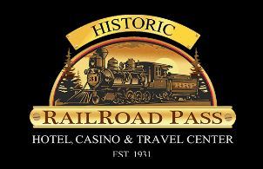
Host Hotel

Discounted Rates Available

For Questions, Please Contact:
George Rosenbaum, Team Coordinator (702) 371-6824 or grosenbaum68@gmail.com

Rev. 3/09/21

